FTK Imager Toolbar

For an examiner, access to the common features quickly is of great benefit. FTK Imager has the icon view by default called Tool Bar.

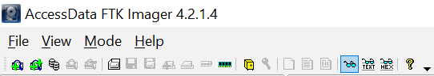

1. Adding an **evidence item** is very simple and easy by clicking the icon  or we can add **all the attached devices** on the evidence computer (like C, D, E drives or USB, etc) by clicking the icon  .
2. FTK Imager provides an important feature that is, its image mounting function. The image mounting function allows the investigator to mount foreign file systems to windows, run Antivirus software, make virtual writes using a cache file, run 3rd party software against an image and navigate directory structure in Read only mode. We can mount the image using the icon.
3. We can easily remove one evidence item or all the evidences by using the icons .
4. Create disk images, Export disk image, Export logical image, Add to custom content image, create custom content image, Verify disk/image these features can be accessed quickly using these  icons respectively.
5. RAM (Random access memory) is the live memory and can be very useful for an investigator to collect evidences. An investigator can capture the live memory if he/she get any computer which is turned on. This feature is provided by the FTK Imager. One can capture RAM quickly using the icon .
6.  The yellow safe like icon is used to Obtain the protected file but only for the live system. And the yellow key icon is used to check the suspect’s computer for Encrypted Files.
7. These icons are used to Export files, Export file hash list and export directory listing.
8. We can change the view type of the file in the viewer using these icons. The icon  is used to automatically select the view type, icon is used to view the file in the plain text format and the icon  is used to view the file in hex format.
9.  These icons are used to get the **User Guide** and **Toolbar options(Show or hide the toolbar).**